**LAB NO 5**

**SUBMITTED BY:**

**RABEEA FATIMA  
REGISTRATION NO: 2023-BSE-049**

**SECTION: B  
SUBJECT: CLOUD COMPUTING**

**TASK 01:**

**Discover missing commands & install Java.**

Step 1: Run Java command

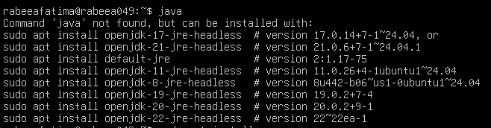



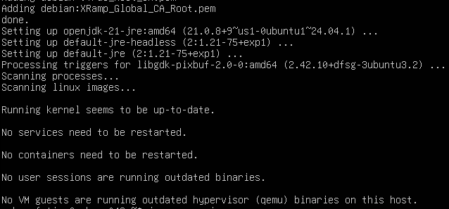

Step 2: Check for Java version installed



Step 3: Remove the Java packet.

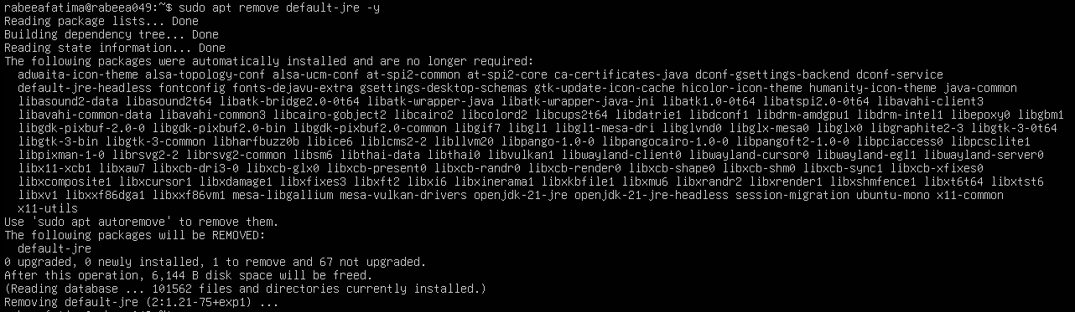

Step 4: Confirm Java is no longer available.

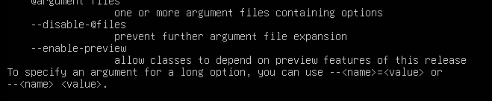

Step 5: Clear shell’s cache.

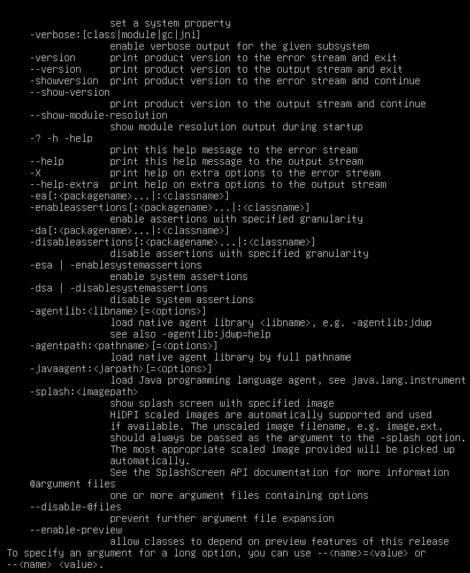

**TASK 02:**

**Install & remove Java explicitly.**

Step 1: Install Java using apt-get command.

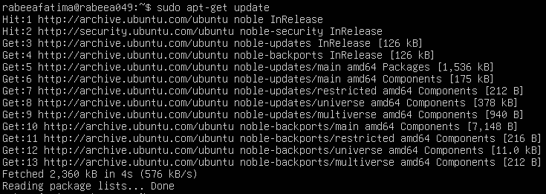

Step 2: Verify Java version again.

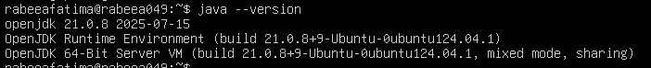

Step 3: Remove Java.

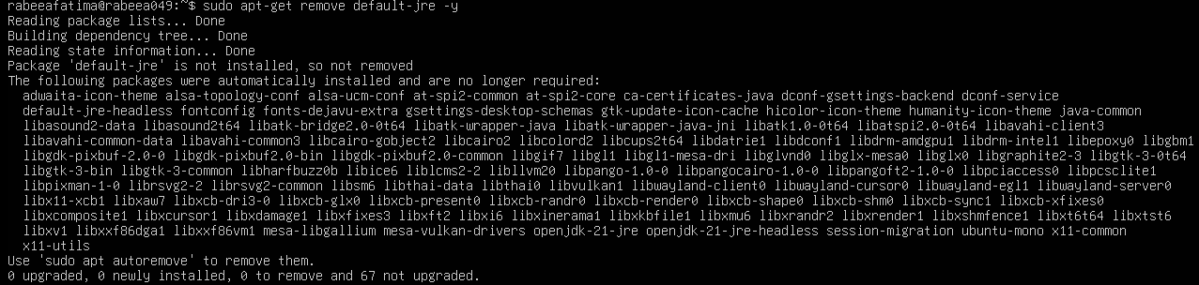

Step 4: Clear cache and confirm java.



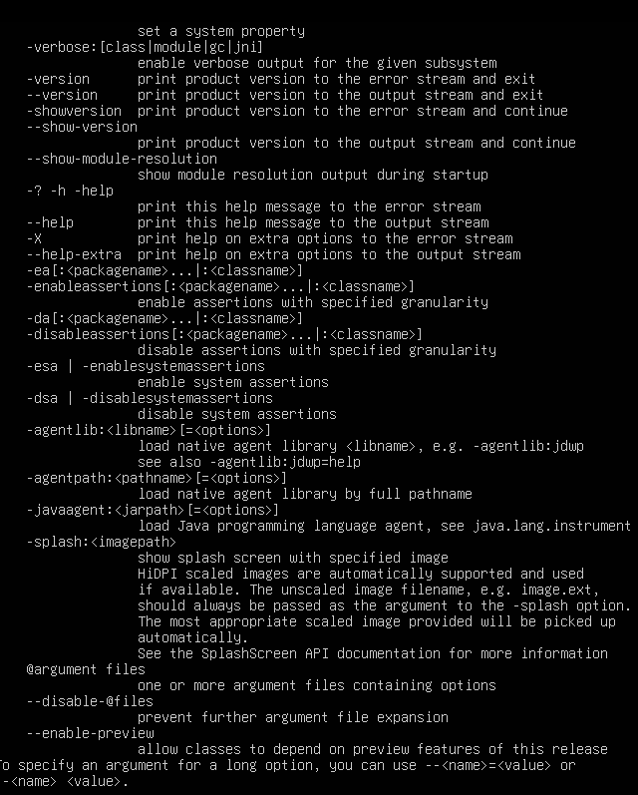

**TASK 03:**

**Apt upgrade vs apt update.**

Step 1: Update the package index.

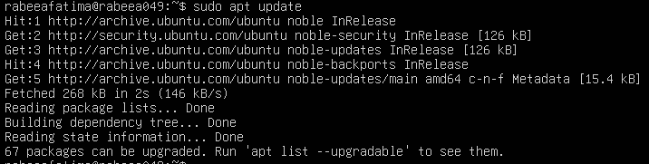

Step 2: Upgrade installed packages.



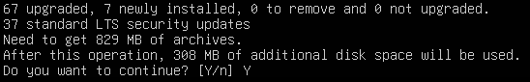

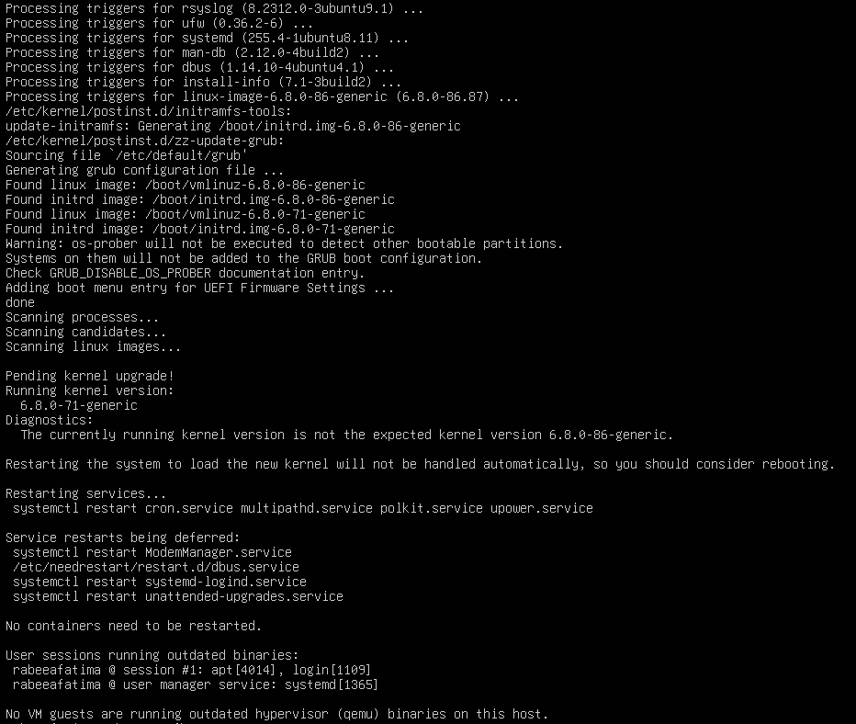

Step 3: Write lines in nano.



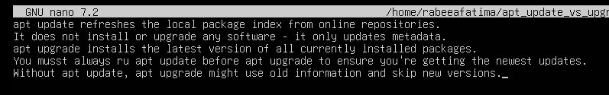

**TASK 04:**

**Install VS code via snap on CLI.**

Step 1: Install VS code.

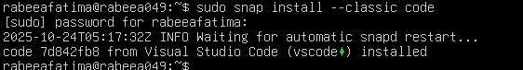

Step 2: Verify snap showing package is installed.

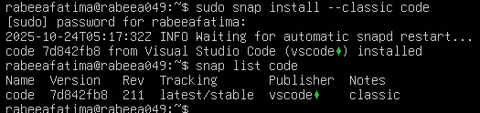

Step 3: Check the installed application’s version.

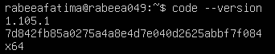

Step 4: Show path.



**TASK 05:**

**Install XFCE GUI + XRDP.**

Step 1: Connect in Command Prompt.

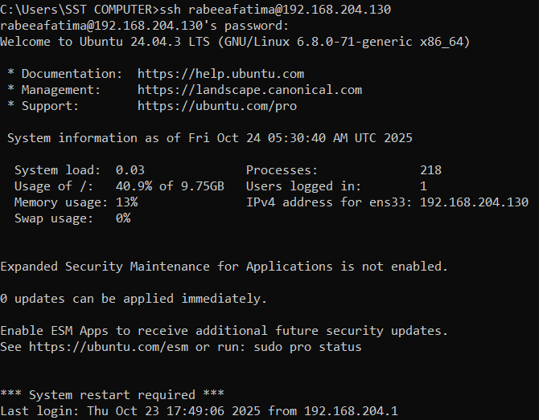

Step 2: Update the server.

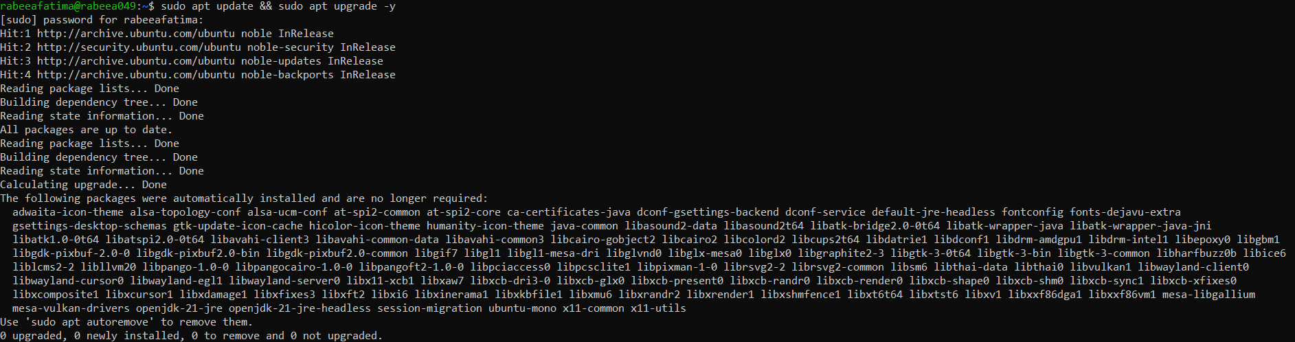

Step 3: Install XFCE & its goodies.

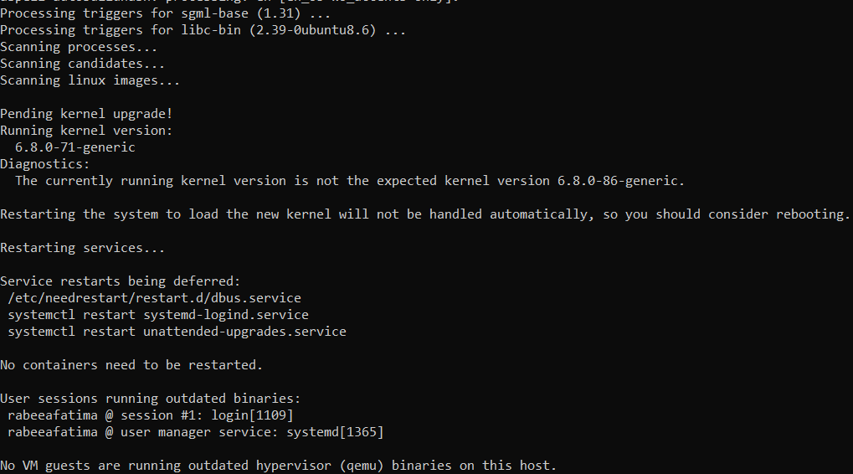

Step 4: Install and enable XRDP.

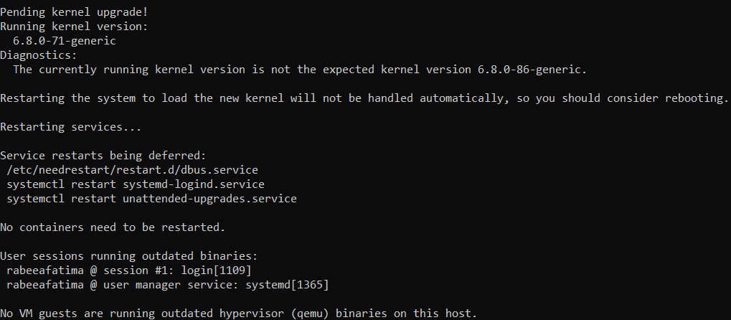

Step 5: Verify XRDP status.

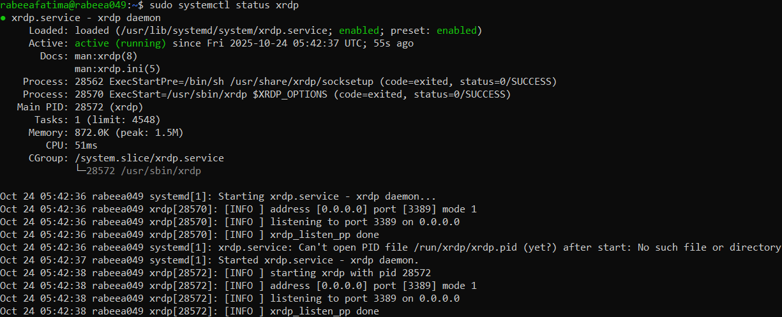

Step 6: Configure XRDP.



Step 7:

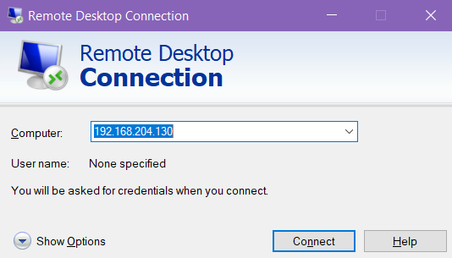

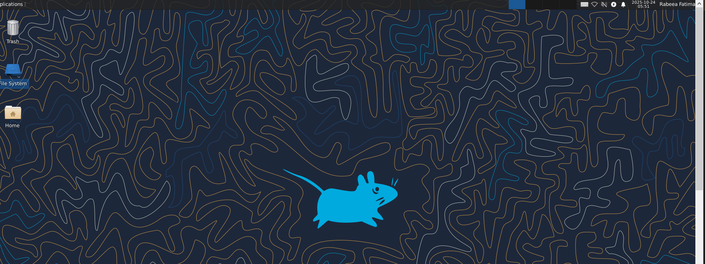

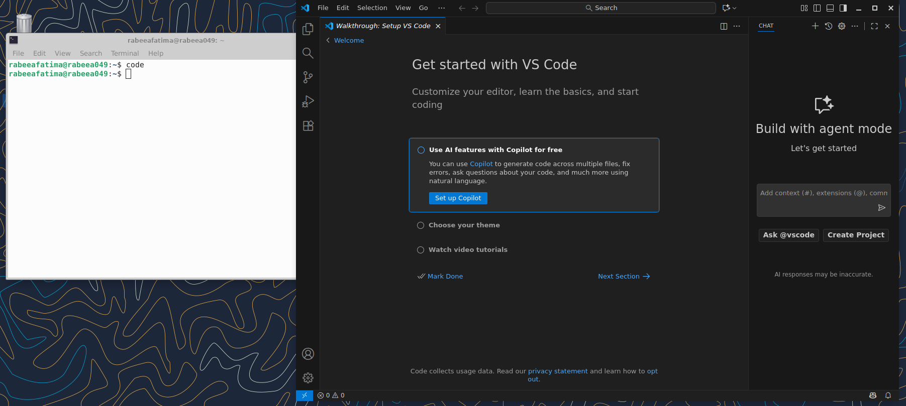

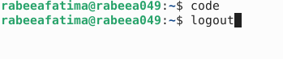

**TASK 06:**

**Install lightdm-gtk-greeter.**

Step 1: Fix GUI login issue.

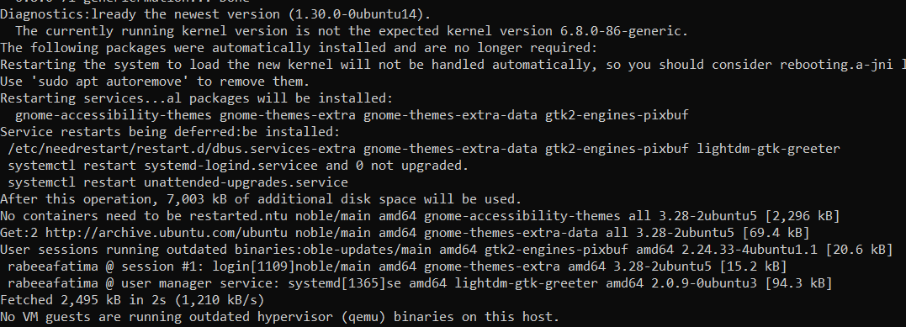



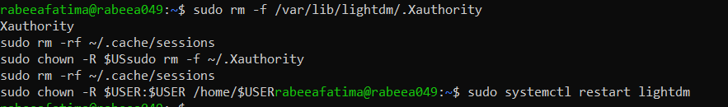

Step 2: Control GUI at boot.

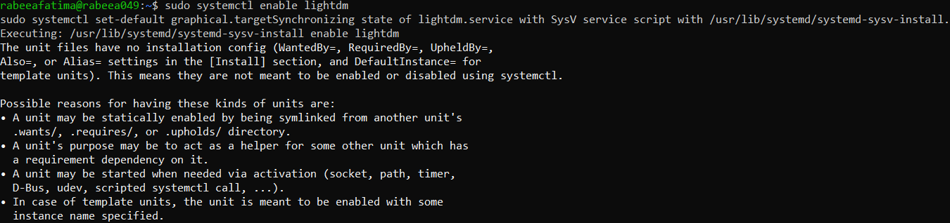

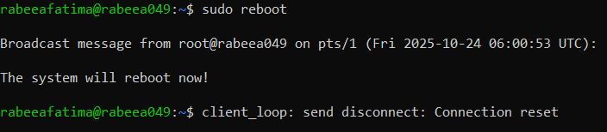

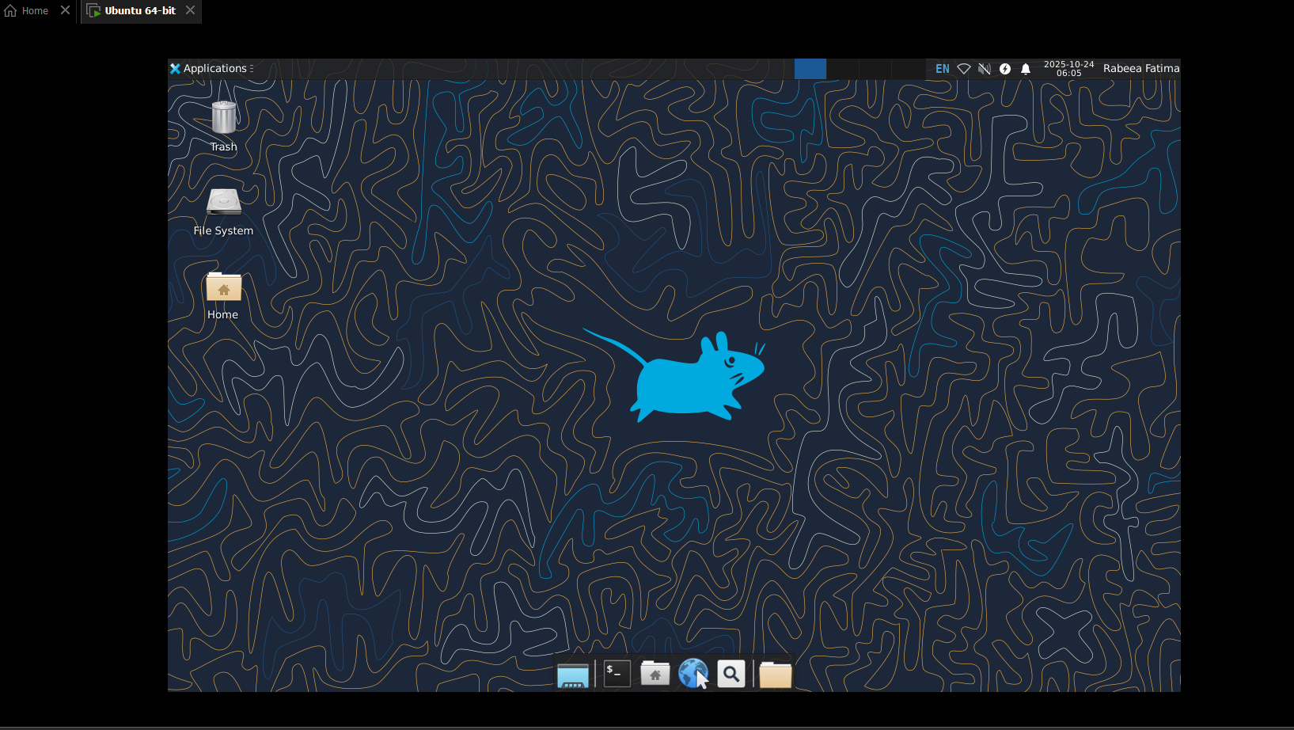

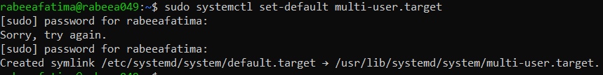

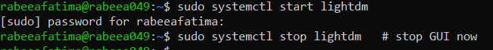

Step 3: Start the GUI and code.

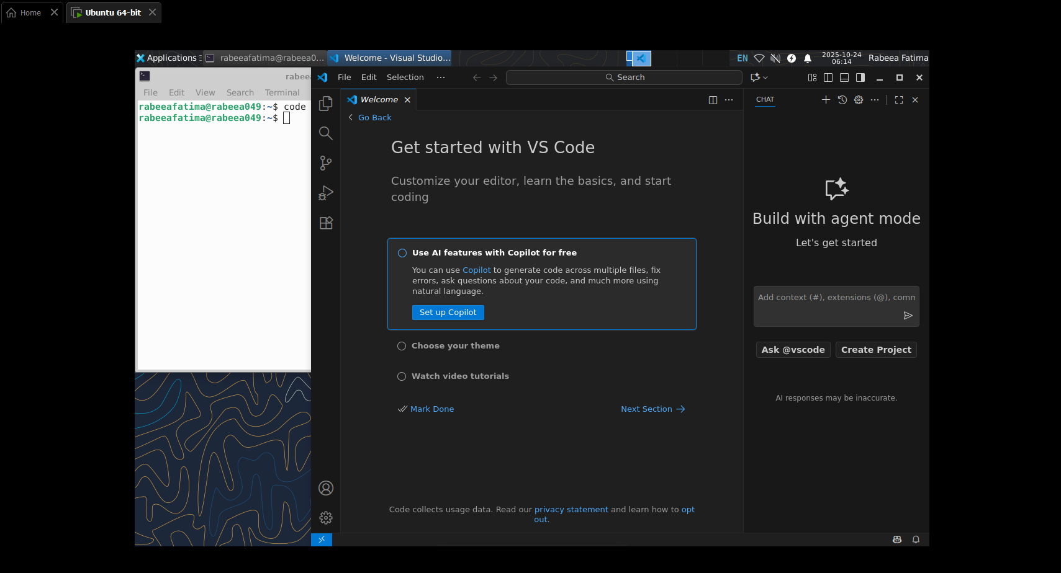

**TASK 07:**

**Install Google Chrome by its apt code & key.**

Step 1: Attempt to install directly.

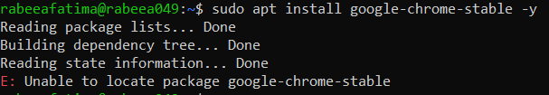

Step 2: Save apt configuration.

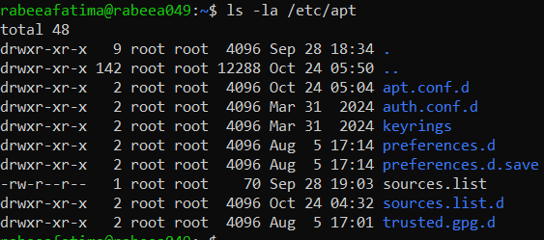

Step 3: View the main.



Step 4: List files.

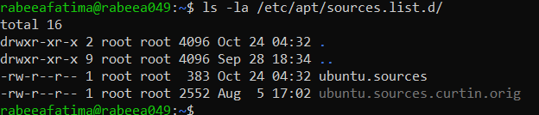

Step 5: Display where file is present.

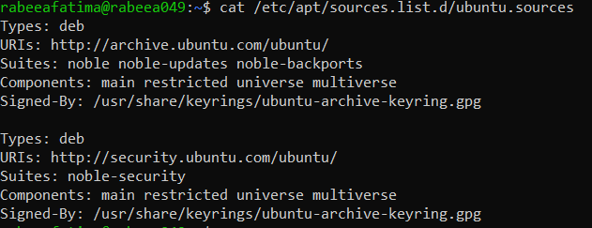

Step 6: Add Chrome repo metadata.

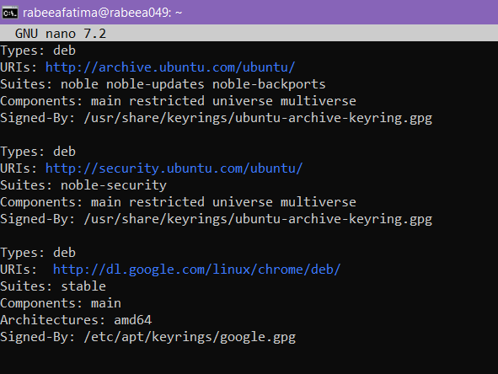

Step 7: Ensure directory exists.



Step 8: Update apt and install chrome again.

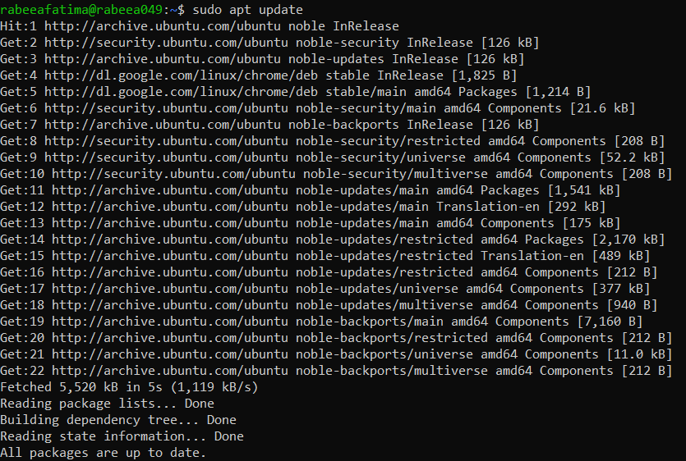

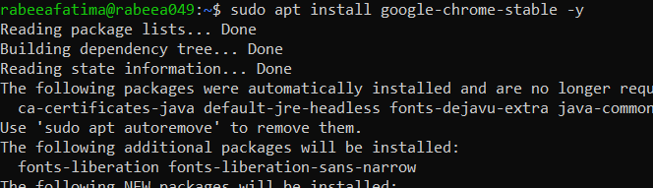

Step 9: Cleanup.

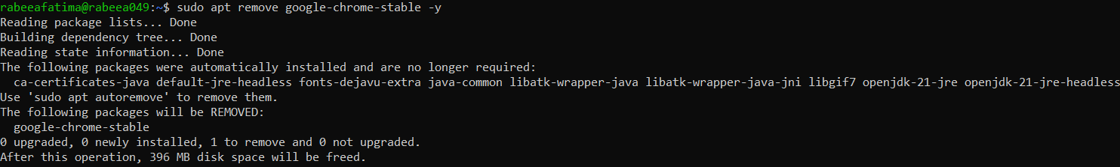



Step 10: Create a dedicated one-line list.



Step 11: Verify the new file exist.

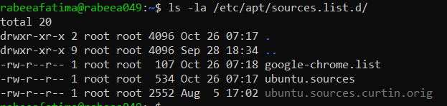

Step 12: Readding the google signing key.



Step 13: Update apt and install Chrome.

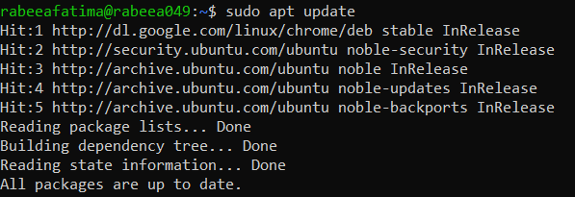

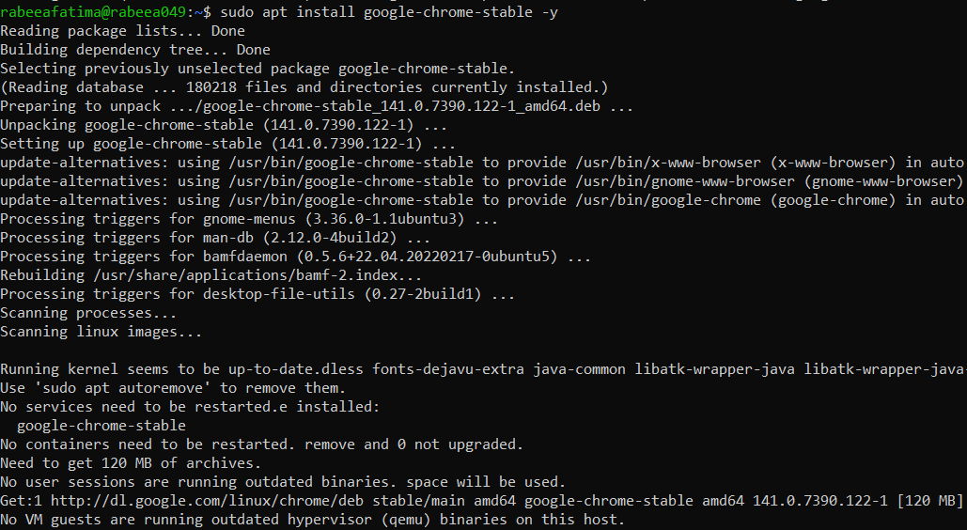

**TASK 08:**

**Install applications via PPA.**

Step 1: Add Audacity PPA. 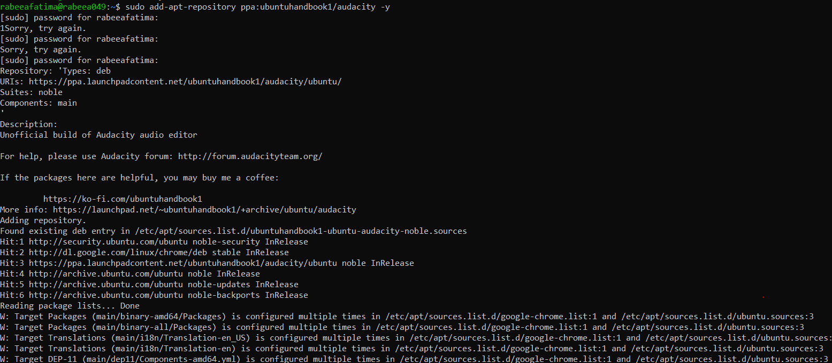

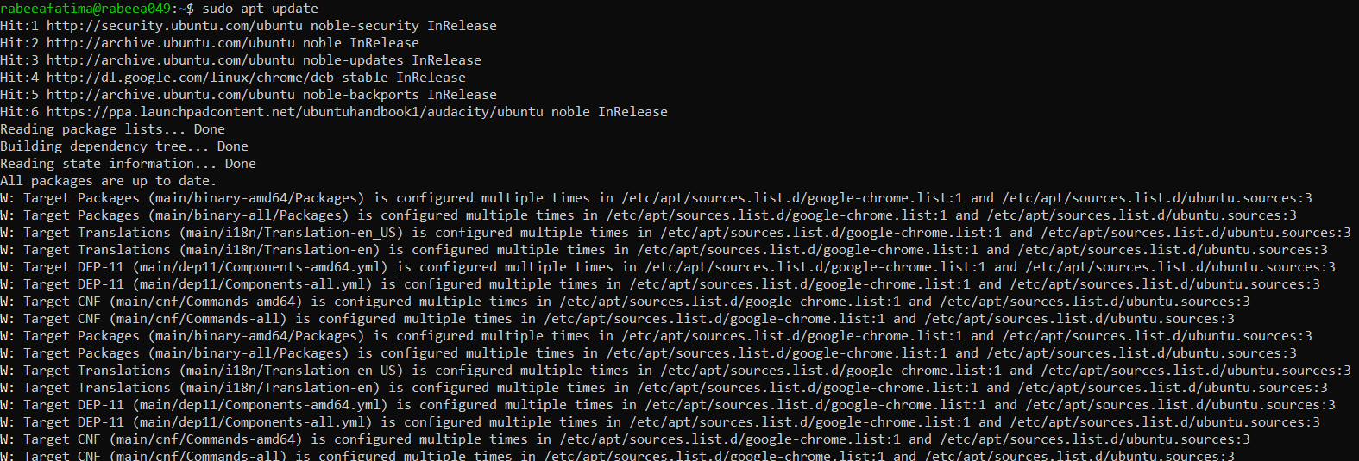

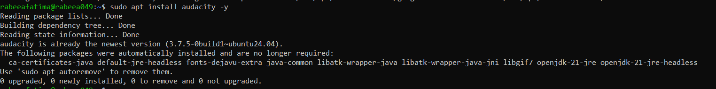

Step 2: Launch Audacity.



Step 3: Add the OBS studio PPA.

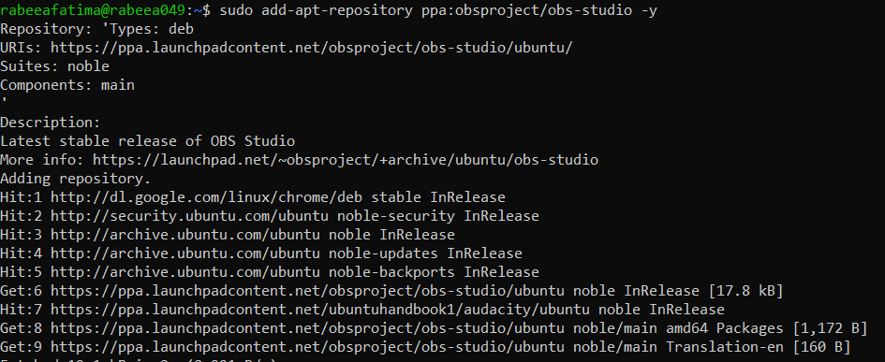

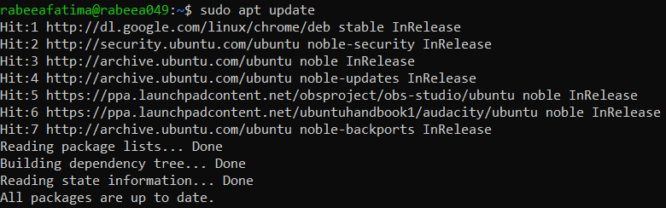

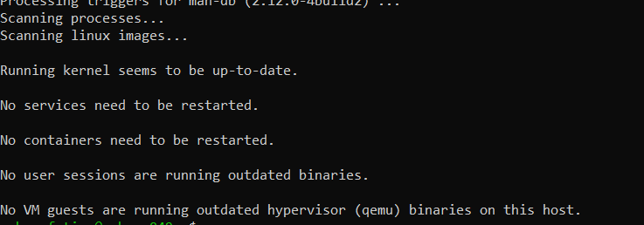

Step 4: Launch OBS Studio.oml

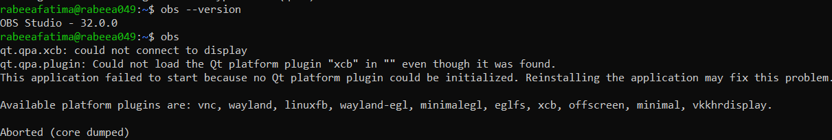

**TASK 09:**

**Create a Kubernetes sample YAML using vim.**

Step 1: Check vim.

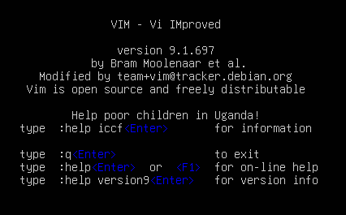

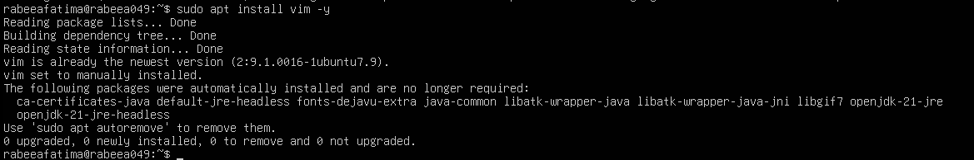

Step 2: Create Lab5 working directory.



Step 3: Create Kubernetes file.

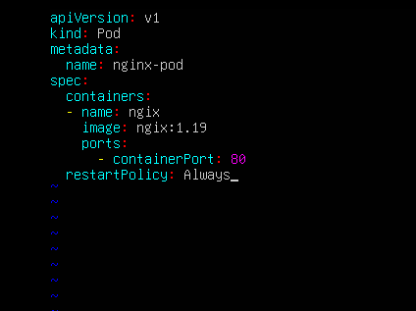



**TASK 10:**

**Edit the Kubernetes YAML.**

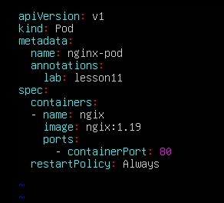

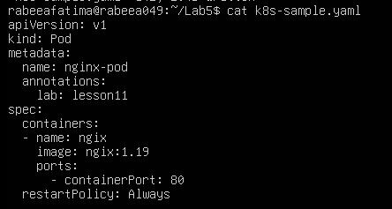

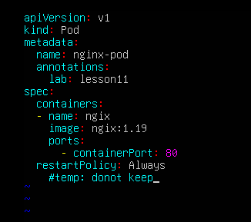

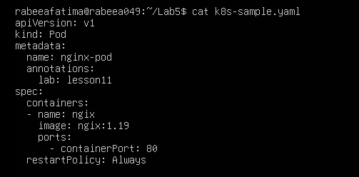

**TASK 11:**

**Vim editing practice.**

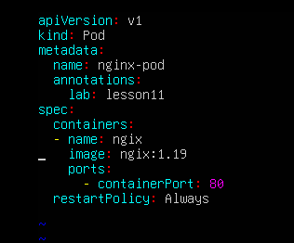

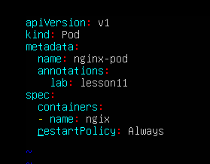







**TASK 12:**

**Vim search, add matches, substitute, undo.**

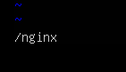

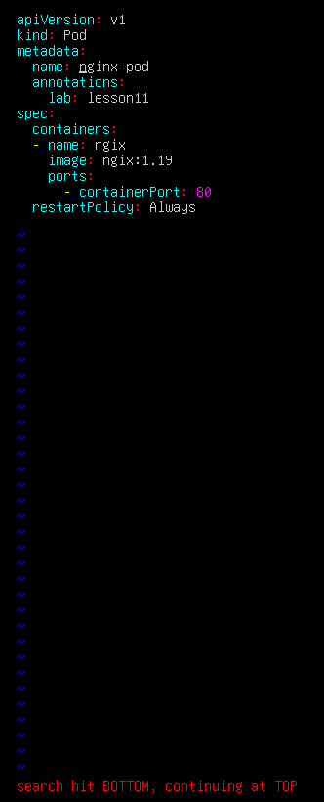

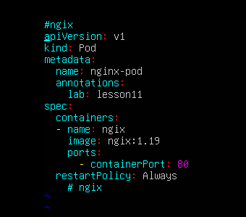

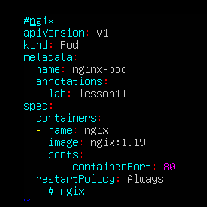



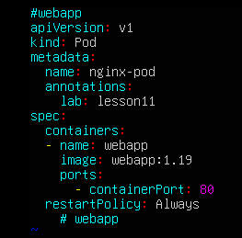

**EXAM EVALUATION QUESTION**

Step 1: Install Docker engine.

